

December 30, 2023

Company  
Address Line 1  
Address Line 2  
City, State, Zip

Cover Letter

Lorem ipsum dolor sit amet, consectetur adipiscing elit. Maecenas facilisis sollicitudin magna at condimentum. Vestibulum at aliquam lorem. Aliquam ut nibh pretium, volutpat metus eu, fermentum velit. Cras dapibus placerat viverra. Etiam faucibus lectus ac neque scelerisque fringilla. Nunc mi velit, tristique ac placerat gravida, porttitor at ante. Phasellus vehicula.

Best Regards,

Eric Foerster's Signature

Eric Foerster CGCS, MG  
TORV, LLC  
970.409.9874  
eric@torv.me



## Green

* The average total available Nitrogen is 4.7 ppm. This is below the optimal range of 5 ppm - 10 ppm for soil nitrogen. Consider additional applications of nitrate or ammonium based fertilizers to increase soil nitrogen levels.
* Deficits were noted in the following 2 measurements: Potassium (ppm) and Phosphorus (ppm). See the “Required element per area” table within the Green section for an indication of how much fertilizer should be added to each sampled area. [TODO: Add custom comment.]
* No other anomalies were highlighted in the analysis. [TODO: Add custom comment.]

## Tee

* The average total available Nitrogen is 4.7 ppm. This is below the optimal range of 5 ppm - 10 ppm for soil nitrogen. Consider additional applications of nitrate or ammonium based fertilizers to increase soil nitrogen levels.
* Deficits were noted in the following 2 measurements: Potassium (ppm) and Sulfur (ppm). See the “Required element per area” table within the Tee section for an indication of how much fertilizer should be added to each sampled area. [TODO: Add custom comment.]
* No other anomalies were highlighted in the analysis. [TODO: Add custom comment.]

## Fairway

* The average total available Nitrogen is 14.2 ppm. This is above the optimal range of 5 ppm - 10 ppm for soil nitrogen. Excessive soil nitrogen may result in unwanted turfgrass growth and increased organic matter.
* No deficits were noted in the values tied to MLSN values. [TODO: Add custom comment.]
* No other anomalies were highlighted in the analysis. [TODO: Add custom comment.]

## Rough

* The average total available Nitrogen is 14.4 ppm. This is above the optimal range of 5 ppm - 10 ppm for soil nitrogen. Excessive soil nitrogen may result in unwanted turfgrass growth and increased organic matter.
* No deficits were noted in the values tied to MLSN values. [TODO: Add custom comment.]
* The average Organic Matter (%) measurement is above 4.5%. [TODO: Add custom comment]

## Organic Matter

The mean OM measurements can be summarised as follows:

* Comparing the **GREEN** samples taken on May 24th, 2023 to their most recent previous samples (October 10th, 2022)
  + At a depth of **0-2 cm**, the OM content decreased from 9.39% to 8.09%
  + At a depth of **2-4 cm**, the OM content decreased from 4.16% to 3.33%
  + At a depth of **4-6 cm**, the OM content decreased from 1.46% to 1.25%
* Comparing the **ROUGH** samples taken on May 24th, 2023 to their most recent previous samples (October 10th, 2022)
  + At a depth of **0-2 cm**, the OM content increased from 21.08% to 23.81%
  + At a depth of **2-4 cm**, the OM content increased from 12.4% to 13.36%
  + At a depth of **4-6 cm**, the OM content decreased from 9.23% to 7.5%
* Comparing the **TEE** samples taken on May 24th, 2023 to their most recent previous samples (October 10th, 2022)
  + At a depth of **0-2 cm**, the OM content increased from 5% to 5.59%
  + At a depth of **2-4 cm**, the OM content increased from 3.95% to 5.05%
  + At a depth of **4-6 cm**, the OM content increased from 2.58% to 3.24%

Like calibrating a TDR measurement for soil moisture content based on subjective observations, the OM246 test should be thought of in the same context. Playability and overall green performance should be considered.

Using a known amount of topdressing applied, we can estimate/calculate the Amount of topdressing needed to maintain, increase, or decrease the organic matter.

* Consider obtaining an accurate topdressing rate per year to make this calculation possible. What is the estimated depth of all topdressing applications applied this year?
* [This video from the USGA](https://www.asianturfgrass.com/post/sand-topdressing-by-depth/) shows how to calculate the depth along with the required conversion equations.
* Cultural decisions such as aerification, verticutting, topdressing amounts/frequency can be influenced by tracking organic matter over time and established goals for organic matter targets.

[TODO: Additional comments]

## Water

* Lorem ipsum dolor sit amet, consectetur adipiscing elit. Maecenas facilisis sollicitudin magna at condimentum. Vestibulum at aliquam lorem. Aliquam ut nibh pretium, volutpat metus eu, fermentum velit.



The temperature data is provided by NOAA using 30-year climate normals and is site-specific to your location. Pace Turf, LLC (Gelernter and Stowell, 2005) developed the growth potential model to explain the myriad of ways in which weather impacts turf growth. The model considers turf growth to be good when the GP is between 50% and 100% (the best possible growth occurs at a GP of 100%). However, when weather conditions are either too hot or too cold for optimal turf growth, the GP falls below 50%, and turf becomes progressively more stressed. When the GP falls to 10% or lower, growth is extremely limited. Appearing below is your model specific to Maroon Creek Club.

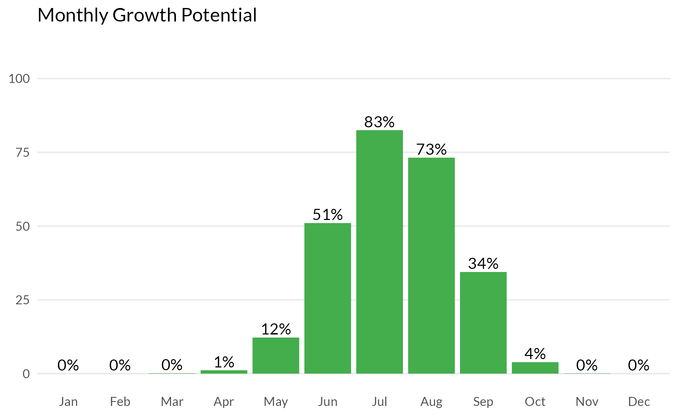



## Measurement results and MLSN values

The following graph shows how the samples taken from each GREEN compare to the calculated MLSN values and required elemental inputs based on the provided nitrogen input and the Turf Growth Potential Model.

* **Red** dots highlight samples where a deficit was found
* **Orange** dots represent samples which are within 1% of the desired MLSN value
* **Green** dots indicate that the samples met the MLSN requirements

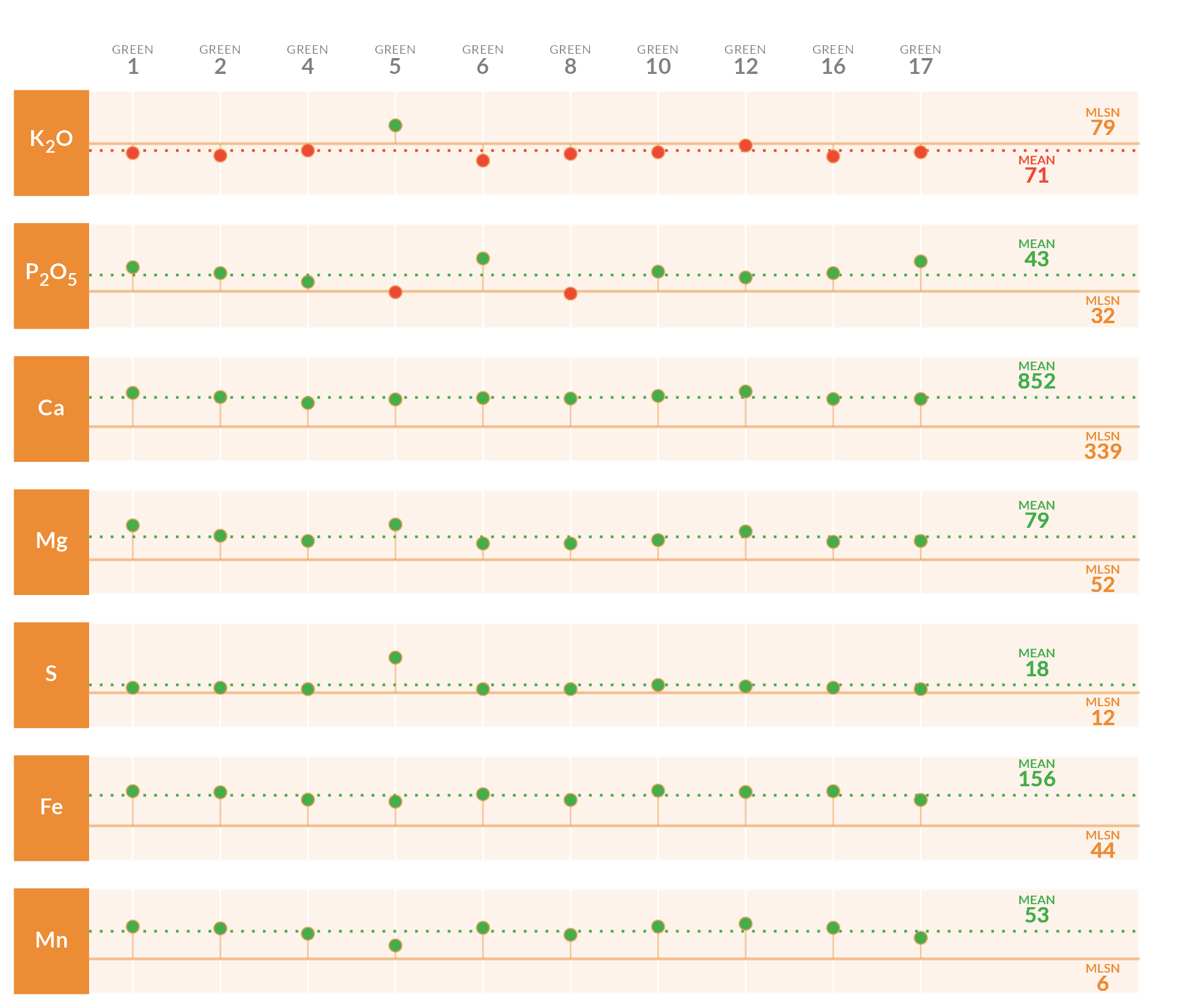

## Required element per area (lbs. per 1000 sq.ft.)

This table specifies the amount of fertilizer required to remedy the deficits highlighted by the analysis.

| **Area** | **K2O** | **P2O5** | **Ca** | **Mg** | **S** | **Fe** | **Mn** |
| --- | --- | --- | --- | --- | --- | --- | --- |
| **1** | 0.41 | - | - | - | - | - | - |
| **2** | 0.52 | - | - | - | - | - | - |
| **4** | 0.3 | - | - | - | - | - | - |
| **5** | - | 0.04 | - | - | - | - | - |
| **6** | 0.74 | - | - | - | - | - | - |
| **8** | 0.45 | 0.11 | - | - | - | - | - |
| **10** | 0.37 | - | - | - | - | - | - |
| **12** | 0.08 | - | - | - | - | - | - |
| **16** | 0.55 | - | - | - | - | - | - |
| **17** | 0.37 | - | - | - | - | - | - |
| **Average** | **0.42** | **0.07** |  |  |  |  |  |
| Note: The symbol " - " means no deficit was found; an empty cell means no data was provided. The Average values are the means across all areas where a deficit was found. | | | | | | | |

## Mean measurements and recommendations

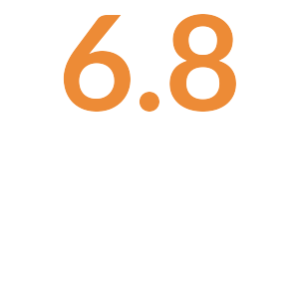

**pH**

The average pH is 6.8. This is within the optimum range for soil microbial activity and soil nutrient availability. With the pH is this range, there is a chance of seeing some iron chlorosis. If this does occur, you can fix it by making foliar applications of ferrous sulfate.

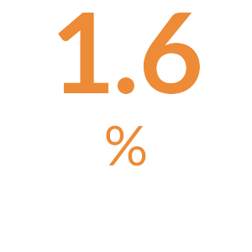

**Organic Matter**

The average Organic Matter is 1.6%. This is normal and indicates that your current maintenance practices are keeping the organic matter percentage in an ideal range.

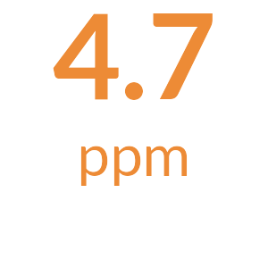

**Total Nitrogen**

The total available Nitrogen measurement is the sum of the Ammonium (NH4-N) and Nitrate (NO3-N) measurements. The average total available Nitrogen is 4.7 ppm. This is below the optimal range of 5 ppm - 10 ppm for soil nitrogen. Consider additional applications of nitrate or ammonium based fertilizers to increase soil nitrogen levels.

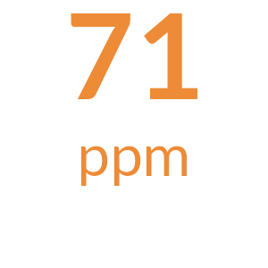

**Potassium**

The mean Potassium (ppm) measurement is 71 ppm; it is below the MLSN value of 79 in the majority of the samples. [Something along the lines of add fertilizer as specified in the table.]

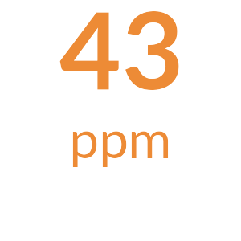

**Phosphorus**

The mean Phosphorus (ppm) measurement is 43 ppm; it is below the MLSN value of 32 in a minority of the samples. [Something along the lines of add fertilizer as specified in the table.]

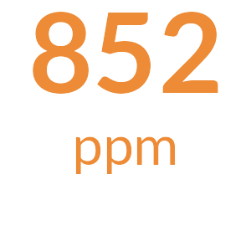

**Calcium**

The mean Calcium (ppm) measurement is 852 ppm and is above the MLSN value of 339 ppm for all the samples. [Something along the lines of all is well.]

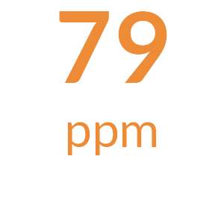

**Magnesium**

The mean Magnesium (ppm) measurement is 79 ppm and is above the MLSN value of 52 ppm for all the samples. [Something along the lines of all is well.]

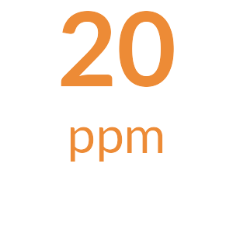

**Sodium**

The average Sodium is 20 ppm. This is below 110 ppm, the beginning threshold for negative effects of sodium on turfgrass.

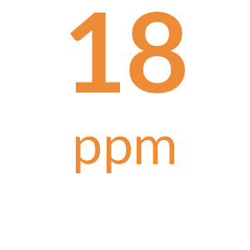

**Sulfur**

The mean Sulfur (ppm) measurement is 18 ppm and is above the MLSN value of 12 ppm for all the samples. [Something along the lines of all is well.]

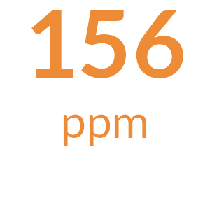

**Iron**

The mean Iron (ppm) measurement is 156 ppm and is above the MLSN value of 44 ppm for all the samples. [Something along the lines of all is well.]

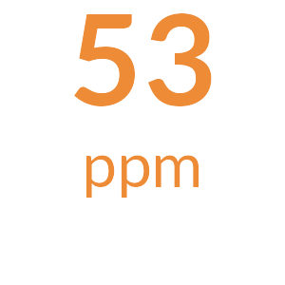

**Manganese**

The mean Manganese (ppm) measurement is 53 ppm and is above the MLSN value of 6.2 ppm for all the samples. [Something along the lines of all is well.]



**Micronutrients**

All Micronutrients are present and there are no recommendations for additional applications.



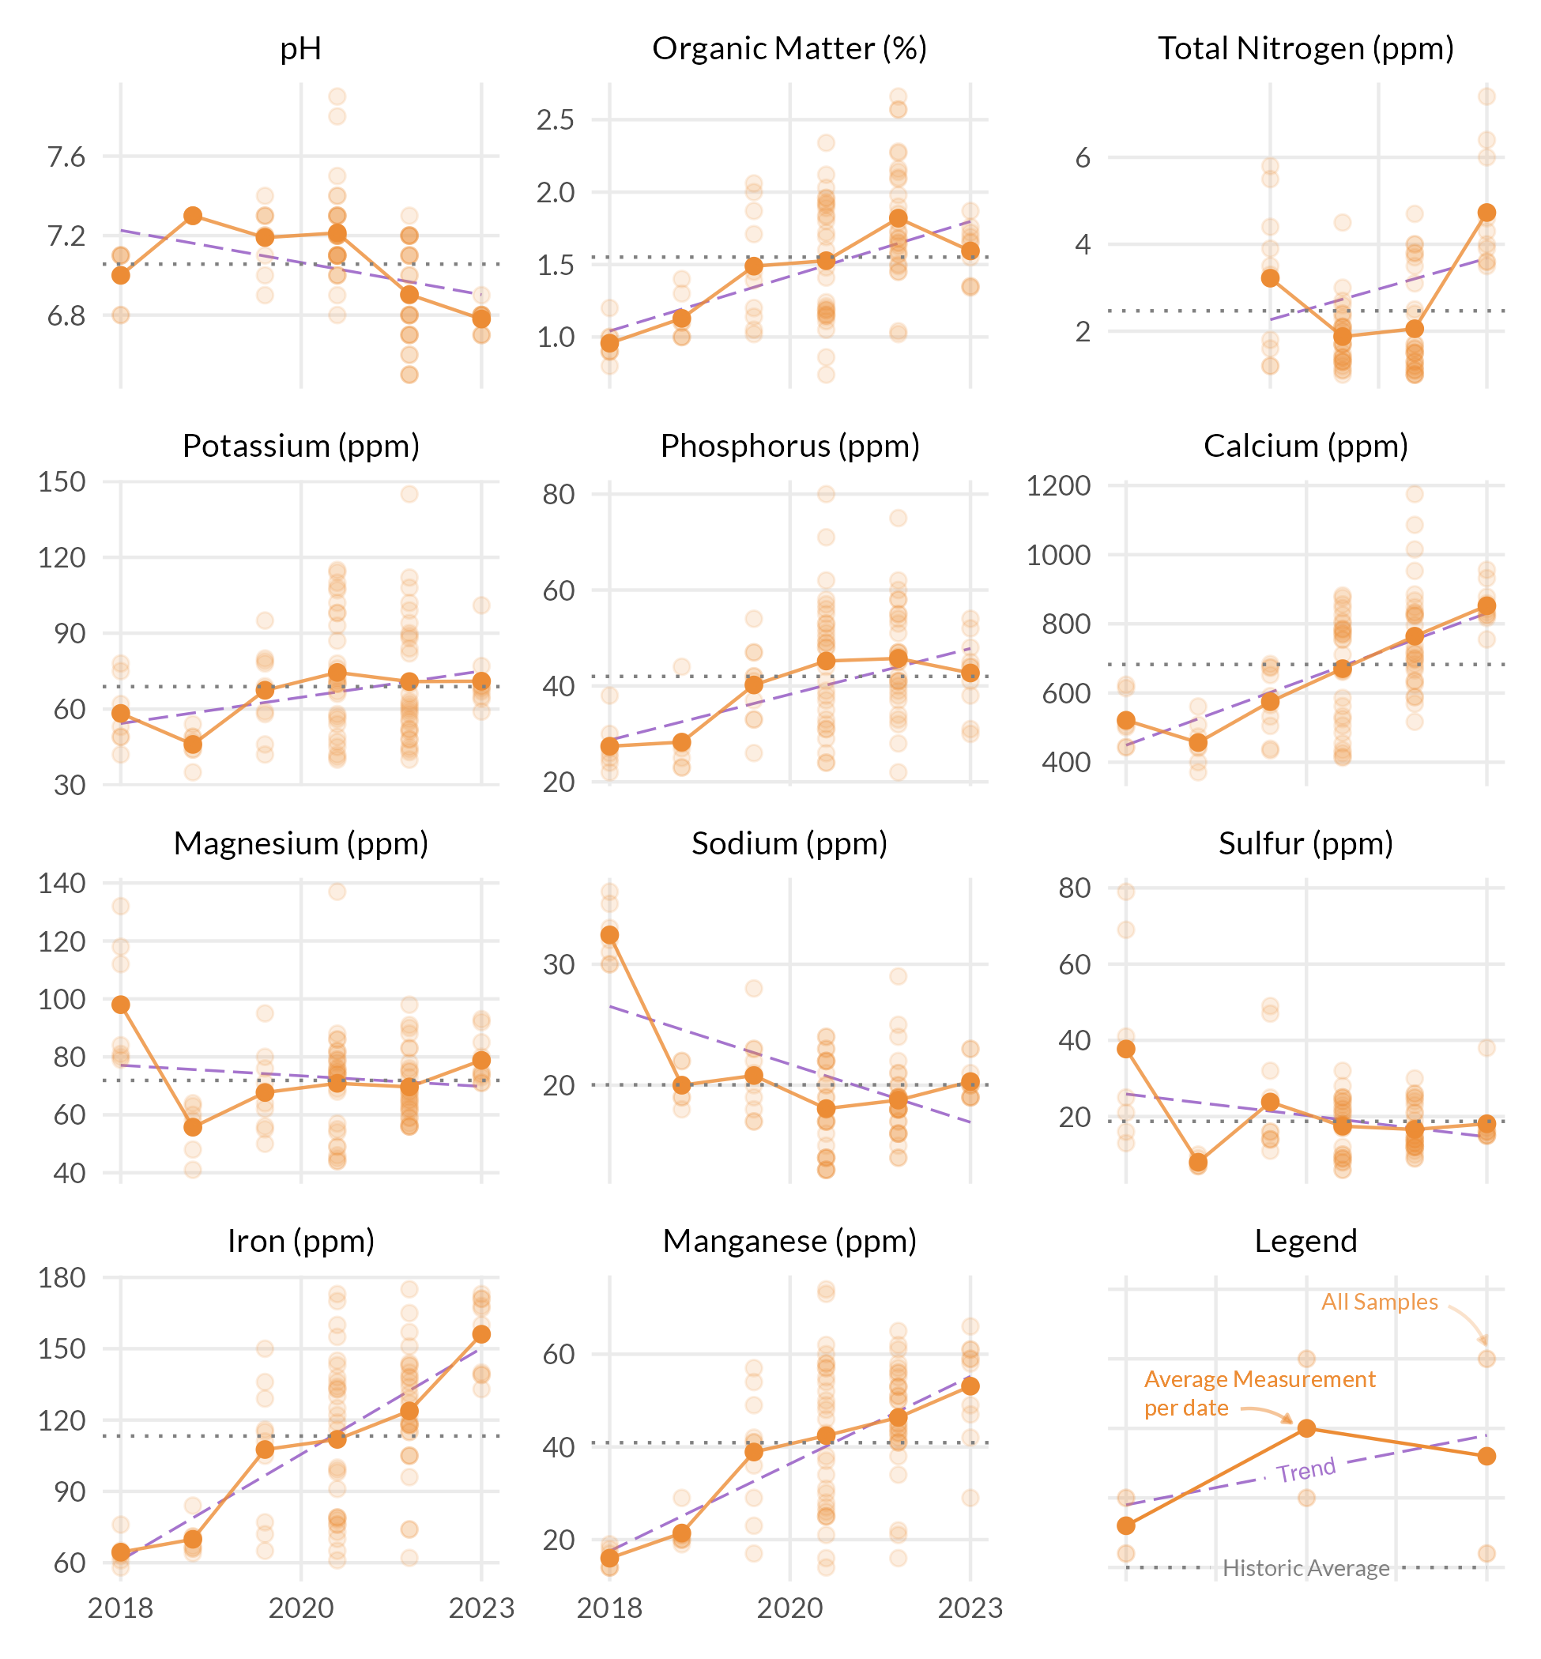



## Measurement results and MLSN values

The following graph shows how the samples taken from each TEE compare to the calculated MLSN values and required elemental inputs based on the provided nitrogen input and the Turf Growth Potential Model.

* **Red** dots highlight samples where a deficit was found
* **Orange** dots represent samples which are within 1% of the desired MLSN value
* **Green** dots indicate that the samples met the MLSN requirements

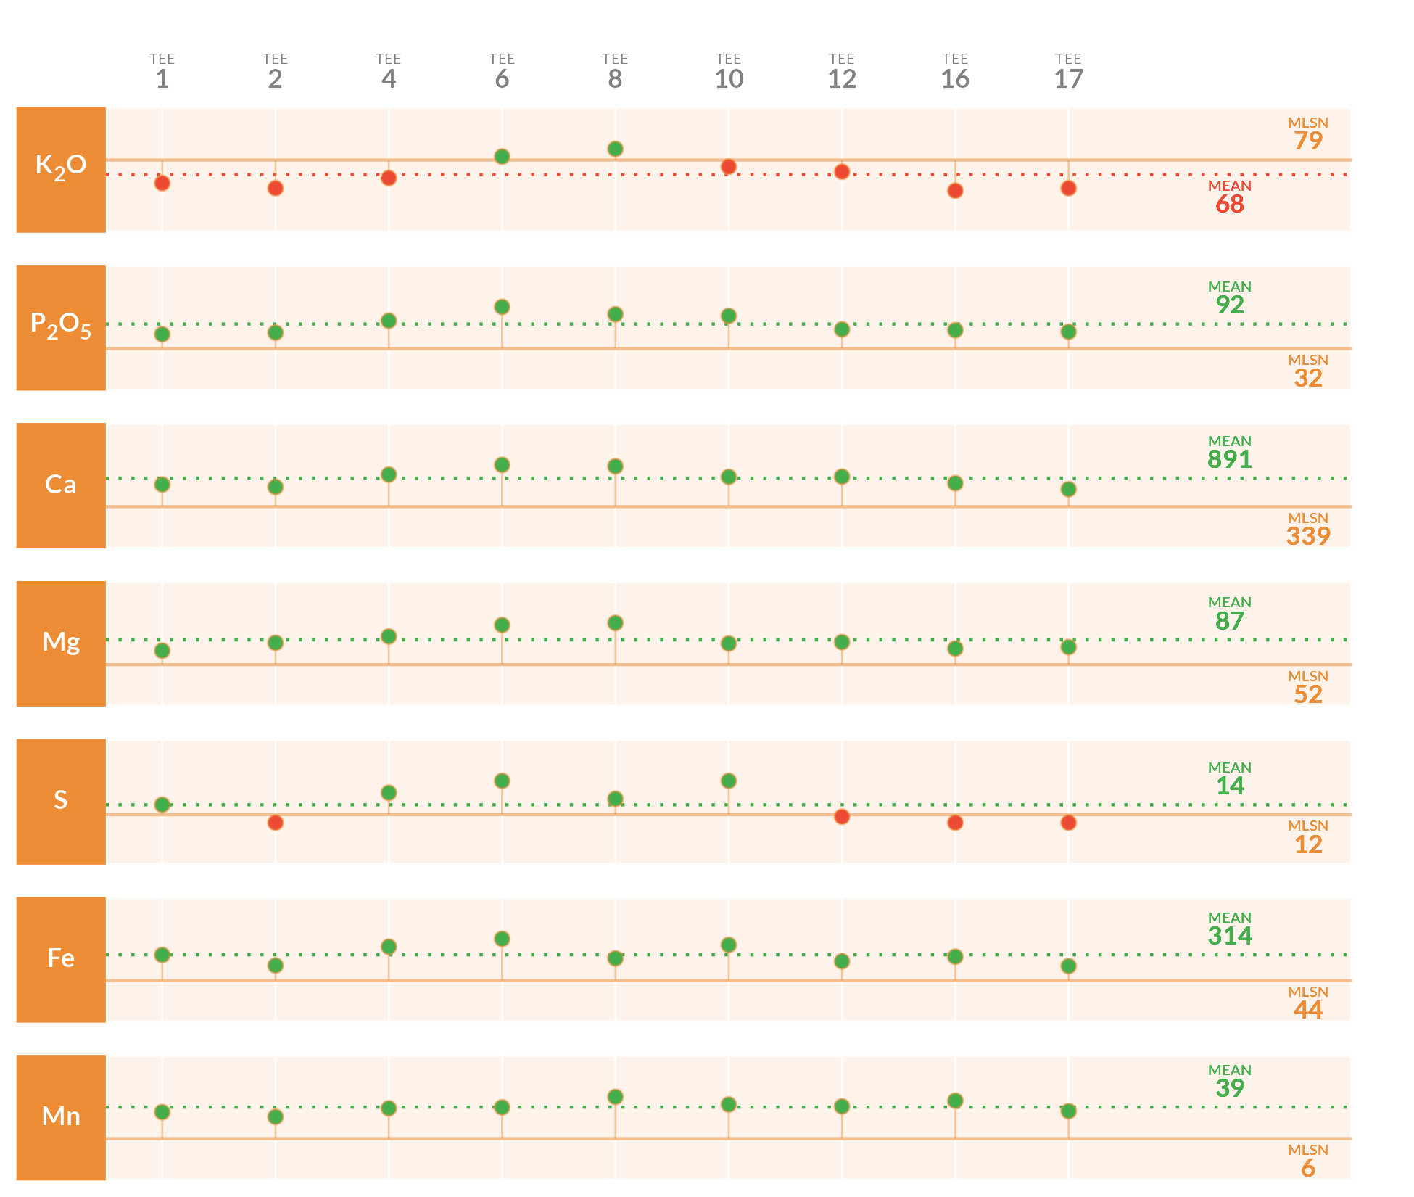

## Required element per area (lbs. per 1000 sq.ft.)

This table specifies the amount of fertilizer required to remedy the deficits highlighted by the analysis.

| **Area** | **K2O** | **P2O5** | **Ca** | **Mg** | **S** | **Fe** | **Mn** |
| --- | --- | --- | --- | --- | --- | --- | --- |
| **1** | 0.66 | - | - | - | - | - | - |
| **2** | 0.81 | - | - | - | 0.04 | - | - |
| **4** | 0.52 | - | - | - | - | - | - |
| **6** | - | - | - | - | - | - | - |
| **8** | - | - | - | - | - | - | - |
| **10** | 0.19 | - | - | - | - | - | - |
| **12** | 0.34 | - | - | - | 0.01 | - | - |
| **16** | 0.88 | - | - | - | 0.04 | - | - |
| **17** | 0.81 | - | - | - | 0.04 | - | - |
| **Average** | **0.6** |  |  |  | **0.03** |  |  |
| Note: The symbol " - " means no deficit was found; an empty cell means no data was provided. The Average values are the means across all areas where a deficit was found. | | | | | | | |

## Mean measurements and recommendations

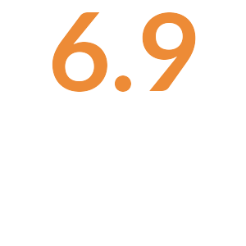

**pH**

The average pH is 6.9. This is within the optimum range for soil microbial activity and soil nutrient availability. With the pH is this range, there is a chance of seeing some iron chlorosis. If this does occur, you can fix it by making foliar applications of ferrous sulfate.

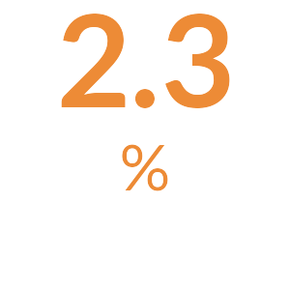

**Organic Matter**

The average Organic Matter is 2.3%. This is normal and indicates that your current maintenance practices are keeping the organic matter percentage in an ideal range.



**Total Nitrogen**

The total available Nitrogen measurement is the sum of the Ammonium (NH4-N) and Nitrate (NO3-N) measurements. The average total available Nitrogen is 4.7 ppm. This is below the optimal range of 5 ppm - 10 ppm for soil nitrogen. Consider additional applications of nitrate or ammonium based fertilizers to increase soil nitrogen levels.

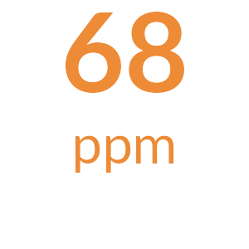

**Potassium**

The mean Potassium (ppm) measurement is 68 ppm; it is below the MLSN value of 79 in the majority of the samples. [Something along the lines of add fertilizer as specified in the table.]

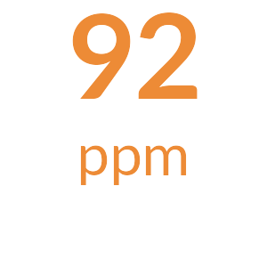

**Phosphorus**

The mean Phosphorus (ppm) measurement is 92 ppm and is above the MLSN value of 32 ppm for all the samples. [Something along the lines of all is well.]

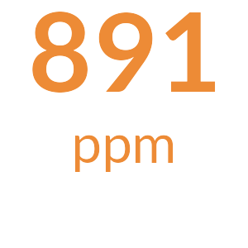

**Calcium**

The mean Calcium (ppm) measurement is 891 ppm and is above the MLSN value of 339 ppm for all the samples. [Something along the lines of all is well.]

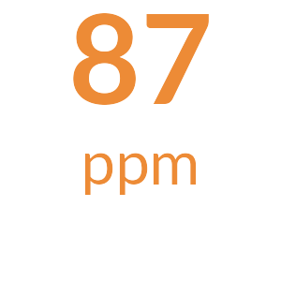

**Magnesium**

The mean Magnesium (ppm) measurement is 87 ppm and is above the MLSN value of 52 ppm for all the samples. [Something along the lines of all is well.]

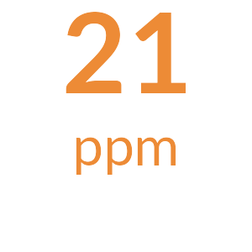

**Sodium**

The average Sodium is 21 ppm. This is below 110 ppm, the beginning threshold for negative effects of sodium on turfgrass.

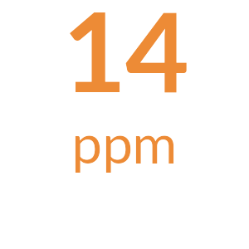

**Sulfur**

The mean Sulfur (ppm) measurement is 14 ppm; it is below the MLSN value of 12 in a minority of the samples. [Something along the lines of add fertilizer as specified in the table.]

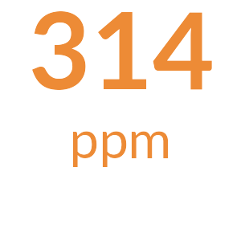

**Iron**

The mean Iron (ppm) measurement is 314 ppm and is above the MLSN value of 44 ppm for all the samples. [Something along the lines of all is well.]

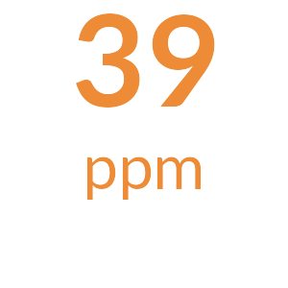

**Manganese**

The mean Manganese (ppm) measurement is 39 ppm and is above the MLSN value of 6.2 ppm for all the samples. [Something along the lines of all is well.]



**Micronutrients**

All Micronutrients are present and there are no recommendations for additional applications.



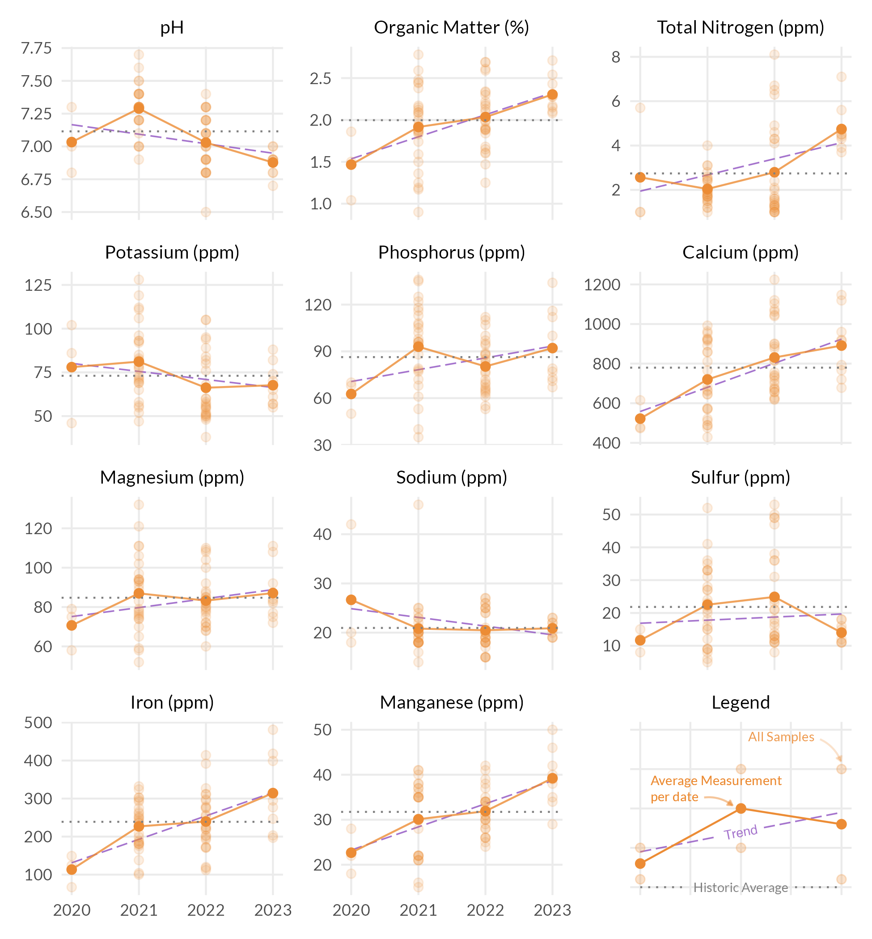



## Measurement results and MLSN values

The following graph shows how the samples taken from each FAIRWAY compare to the calculated MLSN values and required elemental inputs based on the provided nitrogen input and the Turf Growth Potential Model.

* **Red** dots highlight samples where a deficit was found
* **Orange** dots represent samples which are within 1% of the desired MLSN value
* **Green** dots indicate that the samples met the MLSN requirements

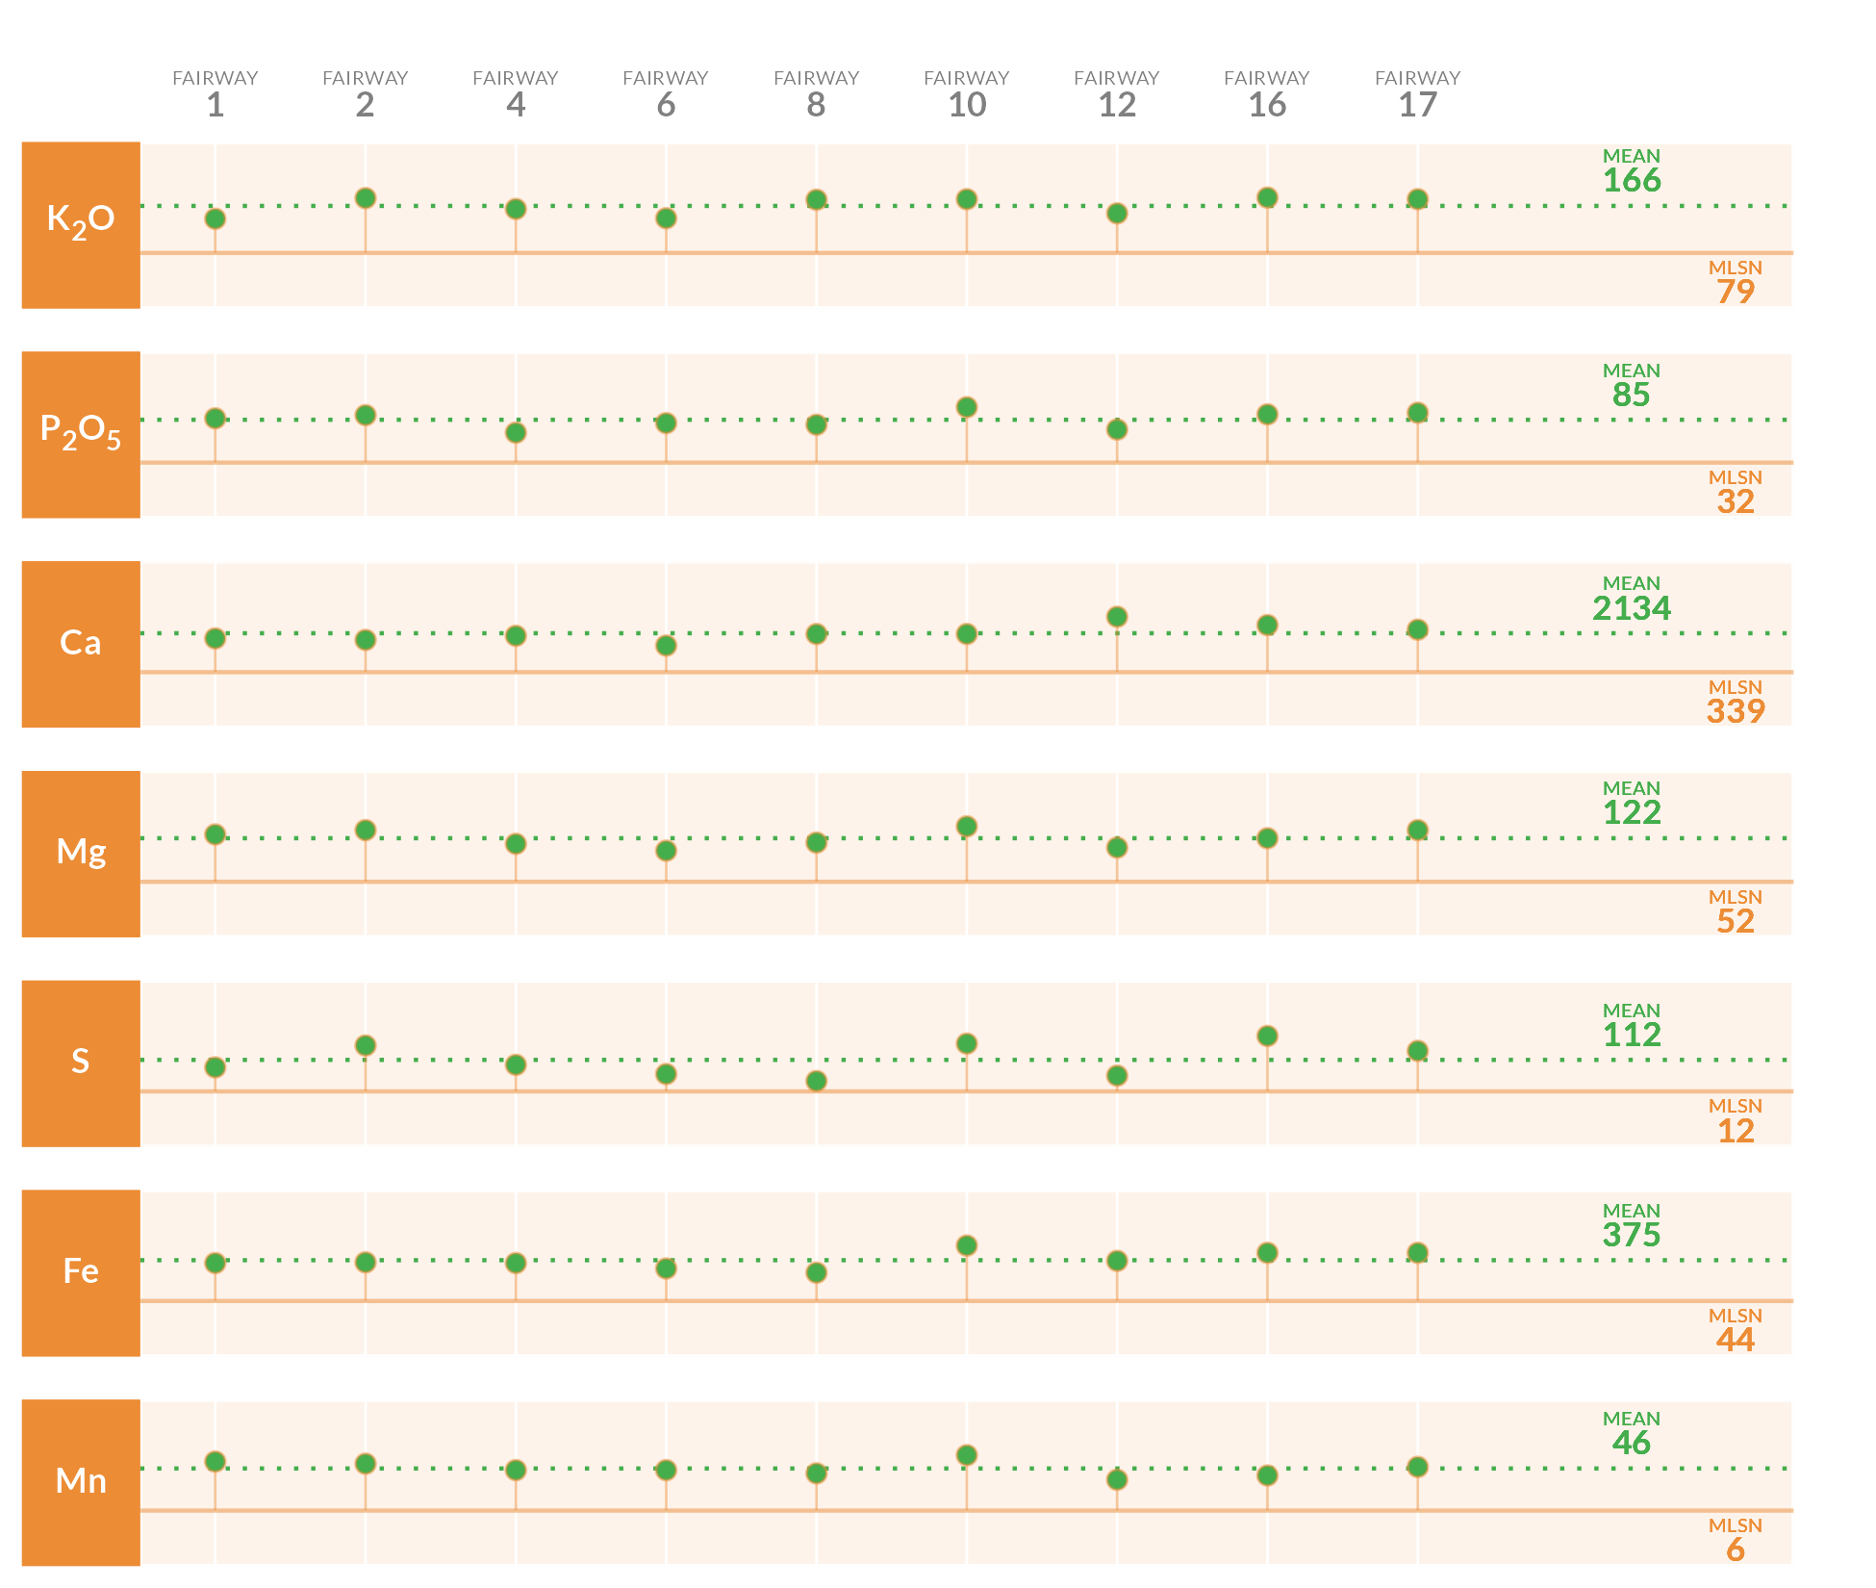

## Required element per area (lbs. per 1000 sq.ft.)

This table specifies the amount of fertilizer required to remedy the deficits highlighted by the analysis.

| **Area** | **K2O** | **P2O5** | **Ca** | **Mg** | **S** | **Fe** | **Mn** |
| --- | --- | --- | --- | --- | --- | --- | --- |
| **1** | - | - | - | - | - | - | - |
| **2** | - | - | - | - | - | - | - |
| **4** | - | - | - | - | - | - | - |
| **6** | - | - | - | - | - | - | - |
| **8** | - | - | - | - | - | - | - |
| **10** | - | - | - | - | - | - | - |
| **12** | - | - | - | - | - | - | - |
| **16** | - | - | - | - | - | - | - |
| **17** | - | - | - | - | - | - | - |
| **Average** |  |  |  |  |  |  |  |
| Note: The symbol " - " means no deficit was found; an empty cell means no data was provided. The Average values are the means across all areas where a deficit was found. | | | | | | | |

## Mean measurements and recommendations



**pH**

The average pH is 7.1. This is within the optimum range for soil microbial activity and soil nutrient availability. With the pH is this range, there is a chance of seeing some iron chlorosis. If this does occur, you can fix it by making foliar applications of ferrous sulfate.

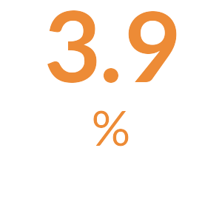

**Organic Matter**

The average Organic Matter is 3.9%. This is normal and indicates that your current maintenance practices are keeping the organic matter percentage in an ideal range.



**Total Nitrogen**

The total available Nitrogen measurement is the sum of the Ammonium (NH4-N) and Nitrate (NO3-N) measurements. The average total available Nitrogen is 14.2 ppm. This is above the optimal range of 5 ppm - 10 ppm for soil nitrogen. Excessive soil nitrogen may result in unwanted turfgrass growth and increased organic matter.

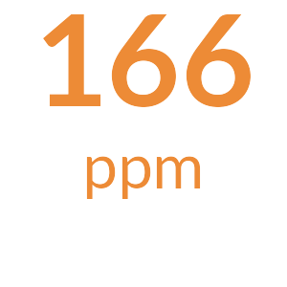

**Potassium**

The mean Potassium (ppm) measurement is 166 ppm and is above the MLSN value of 79 ppm for all the samples. [Something along the lines of all is well.]

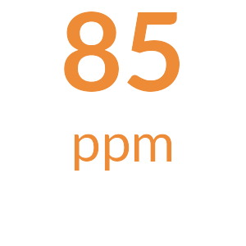

**Phosphorus**

The mean Phosphorus (ppm) measurement is 85 ppm and is above the MLSN value of 32 ppm for all the samples. [Something along the lines of all is well.]

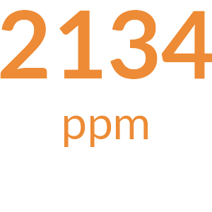

**Calcium**

The mean Calcium (ppm) measurement is 2134 ppm and is above the MLSN value of 339 ppm for all the samples. [Something along the lines of all is well.]

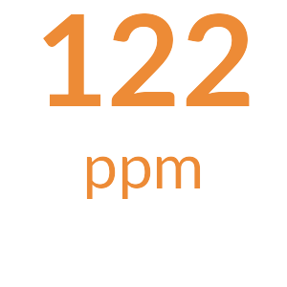

**Magnesium**

The mean Magnesium (ppm) measurement is 122 ppm and is above the MLSN value of 52 ppm for all the samples. [Something along the lines of all is well.]

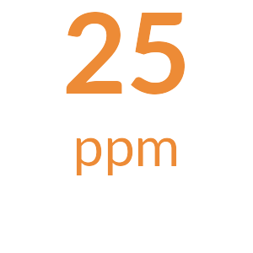

**Sodium**

The average Sodium is 25 ppm. This is below 110 ppm, the beginning threshold for negative effects of sodium on turfgrass.

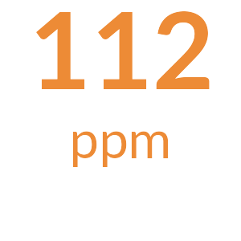

**Sulfur**

The mean Sulfur (ppm) measurement is 112 ppm and is above the MLSN value of 12 ppm for all the samples. [Something along the lines of all is well.]

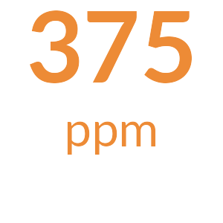

**Iron**

The mean Iron (ppm) measurement is 375 ppm and is above the MLSN value of 44 ppm for all the samples. [Something along the lines of all is well.]

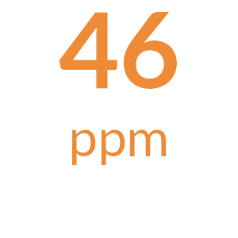

**Manganese**

The mean Manganese (ppm) measurement is 46 ppm and is above the MLSN value of 6.2 ppm for all the samples. [Something along the lines of all is well.]



**Micronutrients**

All Micronutrients are present and there are no recommendations for additional applications.



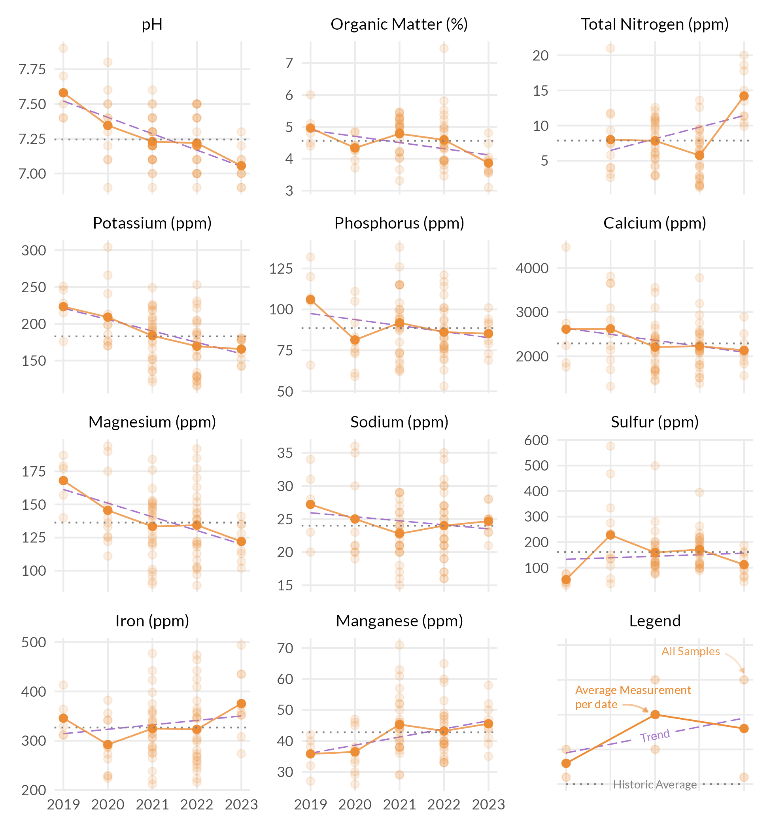



## Measurement results and MLSN values

The following graph shows how the samples taken from each ROUGH compare to the calculated MLSN values and required elemental inputs based on the provided nitrogen input and the Turf Growth Potential Model.

* **Red** dots highlight samples where a deficit was found
* **Orange** dots represent samples which are within 1% of the desired MLSN value
* **Green** dots indicate that the samples met the MLSN requirements

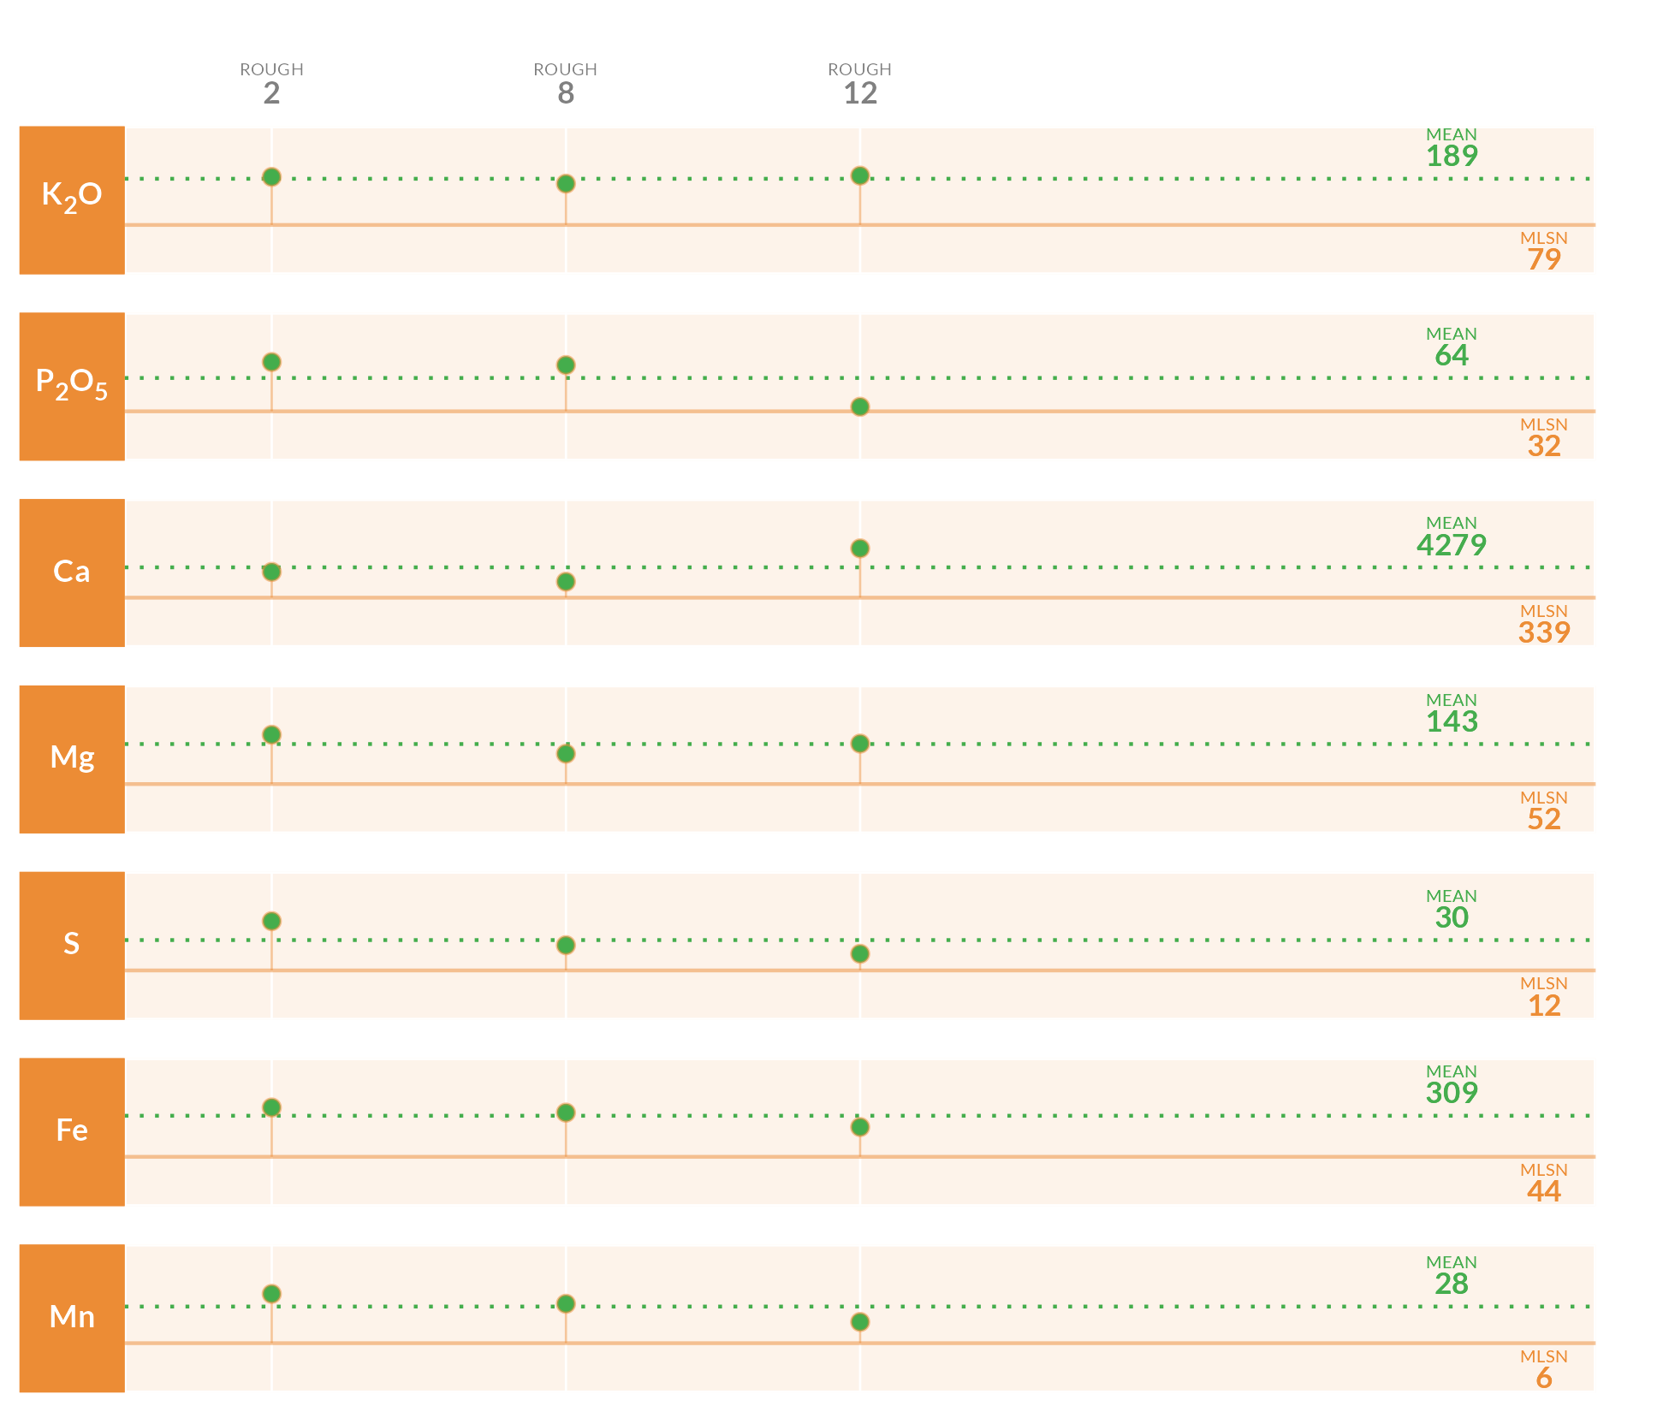

## Required element per area (lbs. per 1000 sq.ft.)

This table specifies the amount of fertilizer required to remedy the deficits highlighted by the analysis.

| **Area** | **K2O** | **P2O5** | **Ca** | **Mg** | **S** | **Fe** | **Mn** |
| --- | --- | --- | --- | --- | --- | --- | --- |
| **2** | - | - | - | - | - | - | - |
| **8** | - | - | - | - | - | - | - |
| **12** | - | - | - | - | - | - | - |
| **Average** |  |  |  |  |  |  |  |
| Note: The symbol " - " means no deficit was found; an empty cell means no data was provided. The Average values are the means across all areas where a deficit was found. | | | | | | | |

## Mean measurements and recommendations



**pH**

The average pH is 7.2. This is within the optimum range for soil microbial activity and soil nutrient availability. With the pH is this range, there is a chance of seeing some iron chlorosis. If this does occur, you can fix it by making foliar applications of ferrous sulfate.

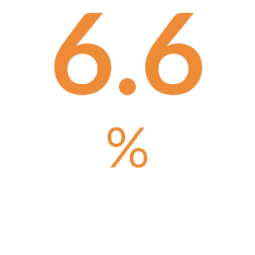

**Organic Matter**

The average Organic Matter (%) measurement is above 4.5%. [TODO: Add custom comment]



**Total Nitrogen**

The total available Nitrogen measurement is the sum of the Ammonium (NH4-N) and Nitrate (NO3-N) measurements. The average total available Nitrogen is 14.4 ppm. This is above the optimal range of 5 ppm - 10 ppm for soil nitrogen. Excessive soil nitrogen may result in unwanted turfgrass growth and increased organic matter.

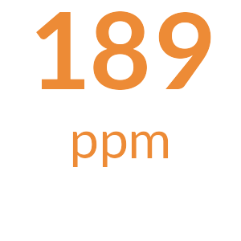

**Potassium**

The mean Potassium (ppm) measurement is 189 ppm and is above the MLSN value of 79 ppm for all the samples. [Something along the lines of all is well.]

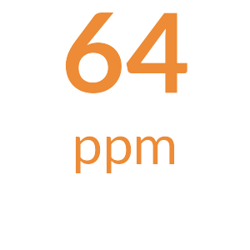

**Phosphorus**

The mean Phosphorus (ppm) measurement is 64 ppm and is above the MLSN value of 32 ppm for all the samples. [Something along the lines of all is well.]

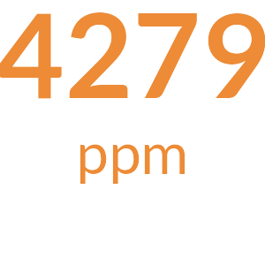

**Calcium**

The mean Calcium (ppm) measurement is 4279 ppm and is above the MLSN value of 339 ppm for all the samples. [Something along the lines of all is well.]

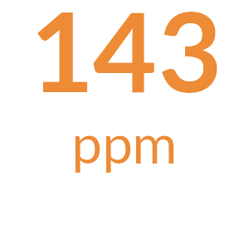

**Magnesium**

The mean Magnesium (ppm) measurement is 143 ppm and is above the MLSN value of 52 ppm for all the samples. [Something along the lines of all is well.]

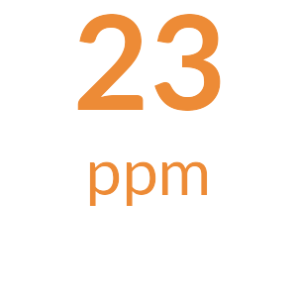

**Sodium**

The average Sodium is 23 ppm. This is below 110 ppm, the beginning threshold for negative effects of sodium on turfgrass.

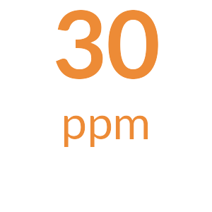

**Sulfur**

The mean Sulfur (ppm) measurement is 30 ppm and is above the MLSN value of 12 ppm for all the samples. [Something along the lines of all is well.]

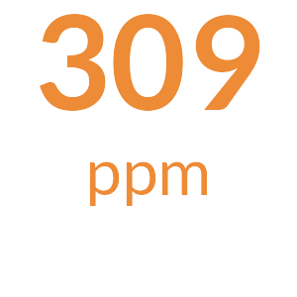

**Iron**

The mean Iron (ppm) measurement is 309 ppm and is above the MLSN value of 44 ppm for all the samples. [Something along the lines of all is well.]

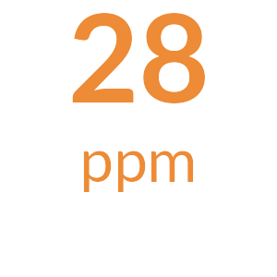

**Manganese**

The mean Manganese (ppm) measurement is 28 ppm and is above the MLSN value of 6.2 ppm for all the samples. [Something along the lines of all is well.]



**Micronutrients**

All Micronutrients are present and there are no recommendations for additional applications.



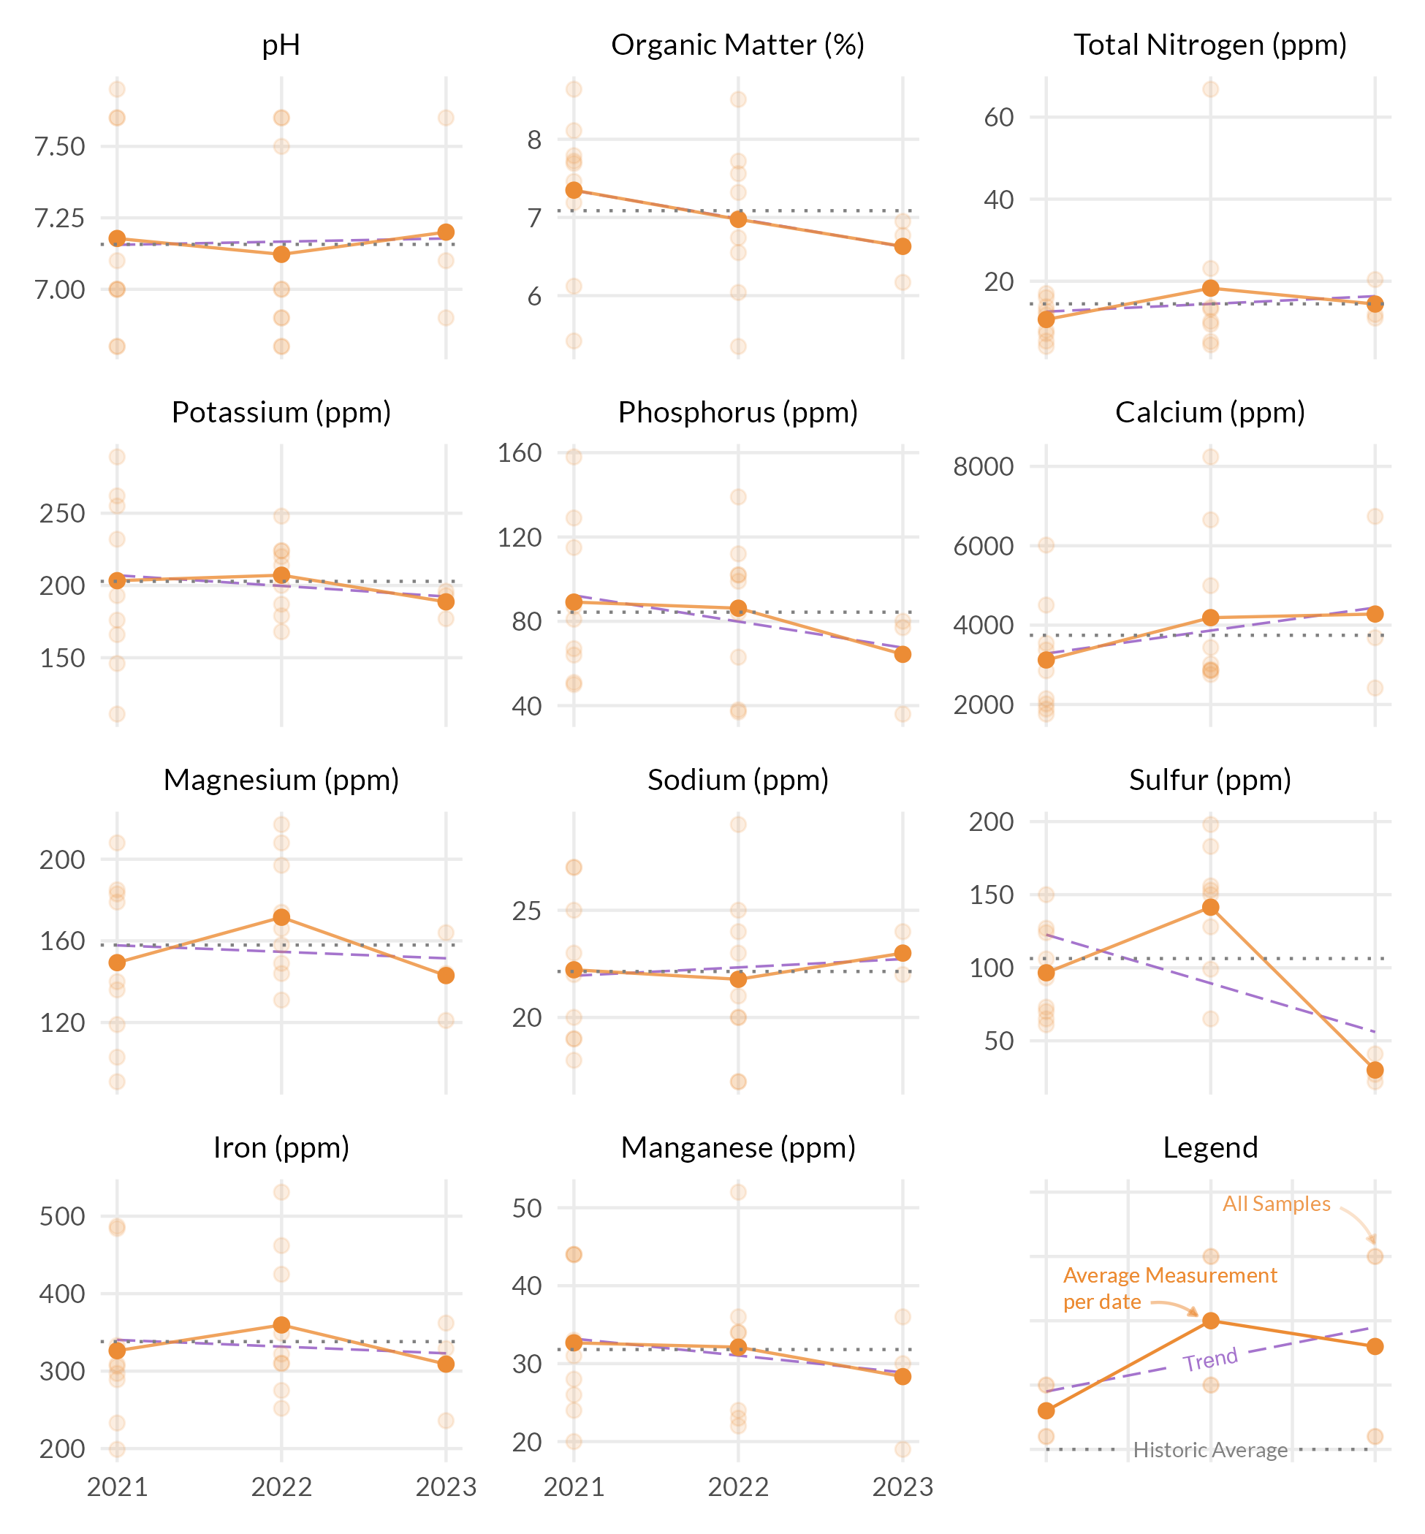



These measurements are neither good nor bad. Information such as fertilizer applied, cultural practices, sand applied, verti-cutting, aerification, etc. can be used to see how these practices have changed the OM% by depth. Ideally, once a desired OM% has been identified based on playability and turf performance, fertility and cultural practices can be adjusted to maintain the desired OM%.

The S325 test package includes the entire sample submitted. This includes leaves, stems, and roots. This differs from the standard soil test which filters out most of the components. This is the reason why the percentages appear higher than that on a standard soil test.

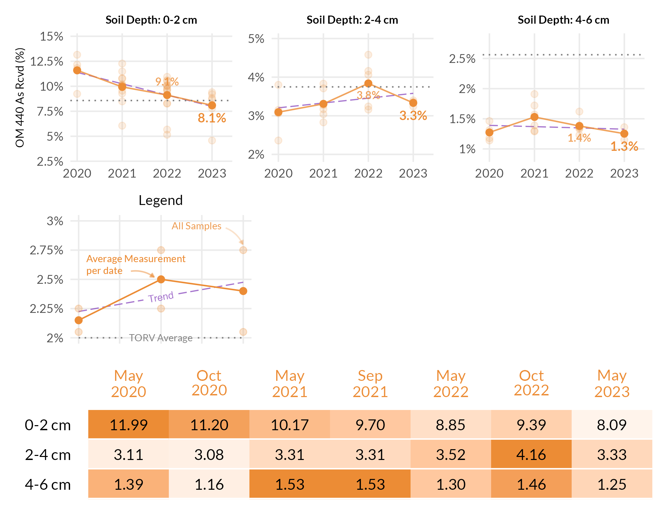



These measurements are neither good nor bad. Information such as fertilizer applied, cultural practices, sand applied, verti-cutting, aerification, etc. can be used to see how these practices have changed the OM% by depth. Ideally, once a desired OM% has been identified based on playability and turf performance, fertility and cultural practices can be adjusted to maintain the desired OM%.

The S325 test package includes the entire sample submitted. This includes leaves, stems, and roots. This differs from the standard soil test which filters out most of the components. This is the reason why the percentages appear higher than that on a standard soil test.

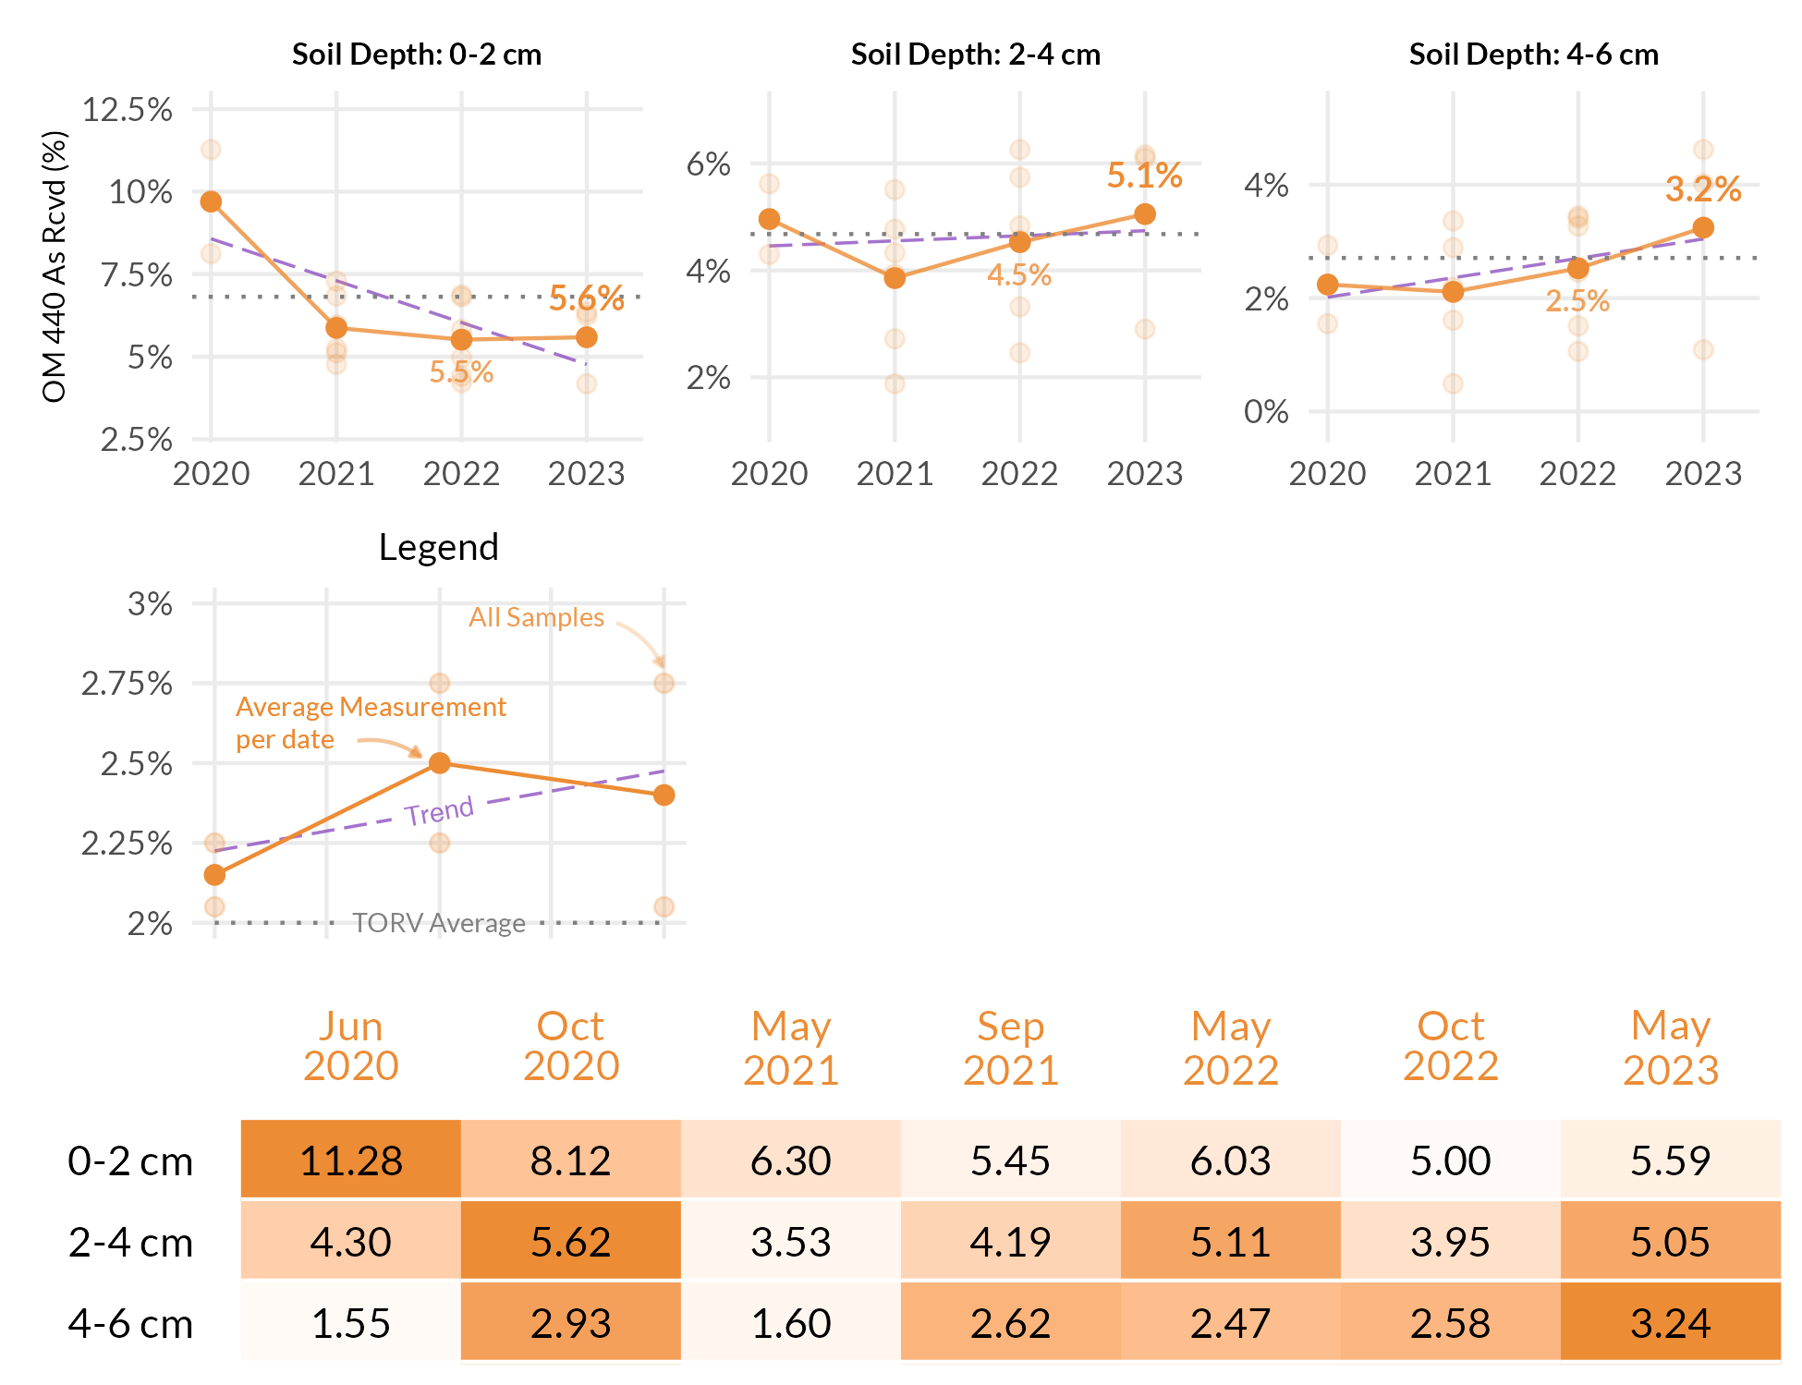



These measurements are neither good nor bad. Information such as fertilizer applied, cultural practices, sand applied, verti-cutting, aerification, etc. can be used to see how these practices have changed the OM% by depth. Ideally, once a desired OM% has been identified based on playability and turf performance, fertility and cultural practices can be adjusted to maintain the desired OM%.

The S325 test package includes the entire sample submitted. This includes leaves, stems, and roots. This differs from the standard soil test which filters out most of the components. This is the reason why the percentages appear higher than that on a standard soil test.

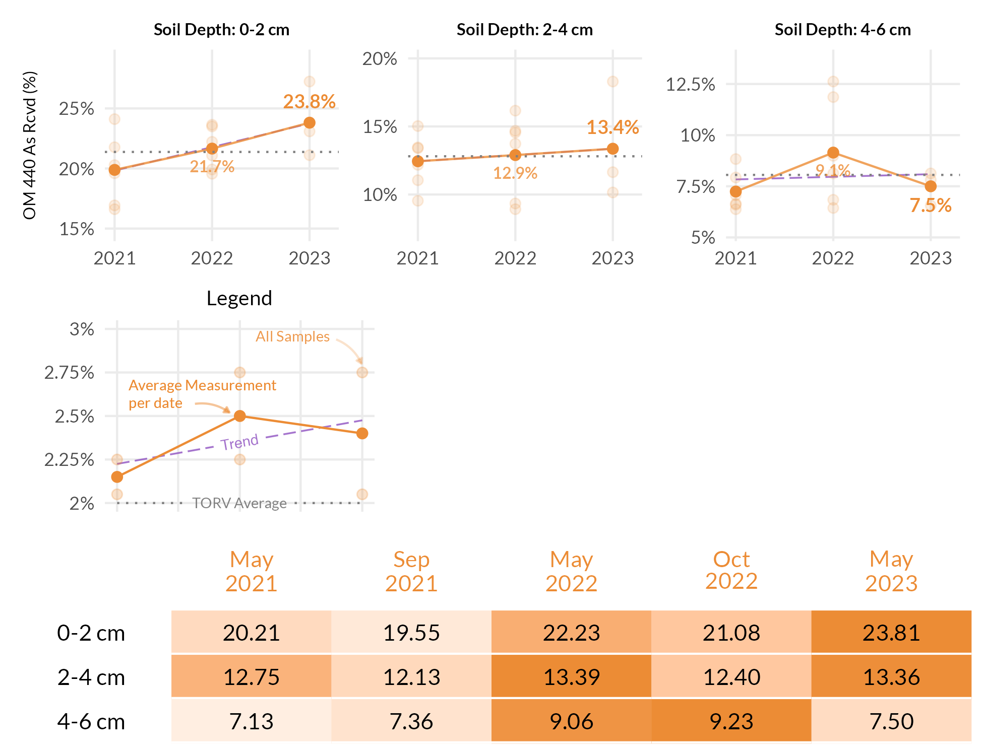



FAO Handbook 29 is the Food and Agricultural Organization of the United Nations and widely is recognized as the leading source for irrigation water quality guidelines. Below are the water sample results as shown in comparison to the FAO guidelines for likelihood of soil problems.

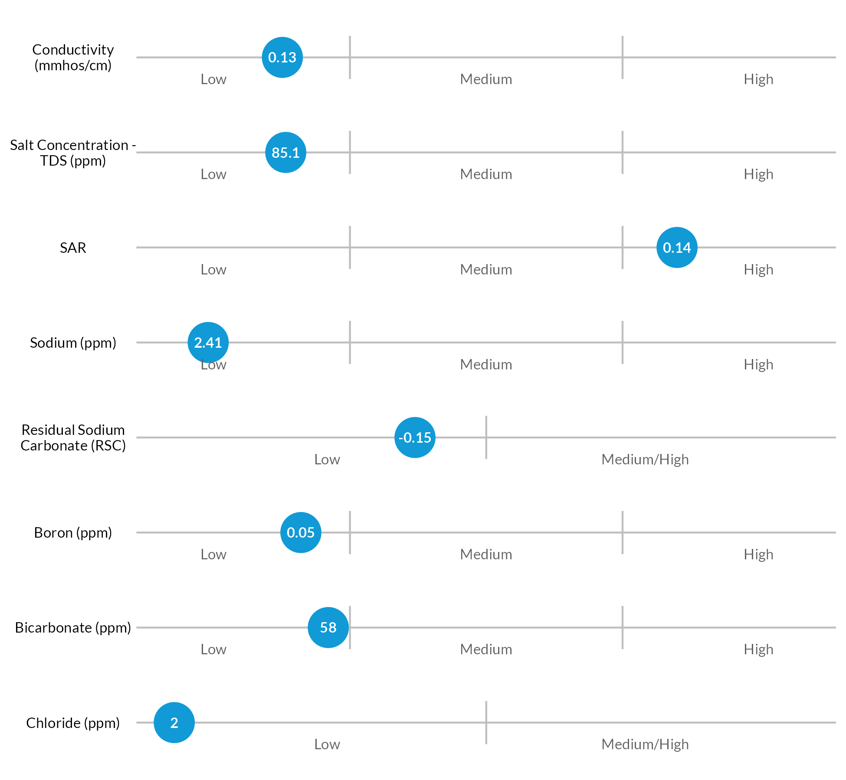



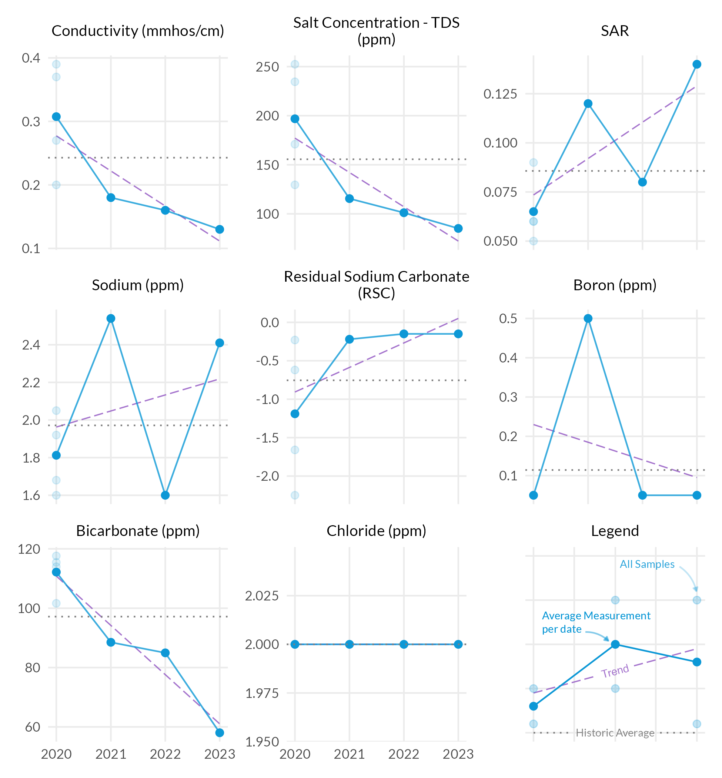



FAO Handbook 29 is the Food and Agricultural Organization of the United Nations and widely is recognized as the leading source for irrigation water quality guidelines. Below are the water sample results as shown in comparison to the FAO guidelines for likelihood of soil problems.

